**Rajkiya Engineering College, Azmagrah**

**One Day Workshop Sponsored by TEQIP-III**

**On**

**Women Empowerment**

**under**

**Unnat Bharat Abhiyan- A flagship Programme of MHRD, Government of India on 15/10/2019**

**Report**

**Objectives:**

1. To create awareness among the women’s specially from Rural areas about their importance in overall development of the society.
2. To aware the rural women about their rights and facilities provided by government to them.
3. To motivate the women to increase their participation in social activities.
4. To create awareness among the women about health issues.

**Chief guest:**  Prof. D S Chauhan, former Vice-Chancellor, Uttar Pradesh Technical

University, Uttrakhand Technical University

**Speakers**:

1. Smt. Divya Singh (Director of Atulanand Academy, Varanasi)
2. Dr. S.N. Chaurasia (Scientist, Indian Institute of Vegetable Research, Varanasi)
3. Dr. K.K. Pandey (Scientist, Indian Institute of Vegetable Research, Varanasi)
4. Sri Barrister Ji

**Glimpse of the program**

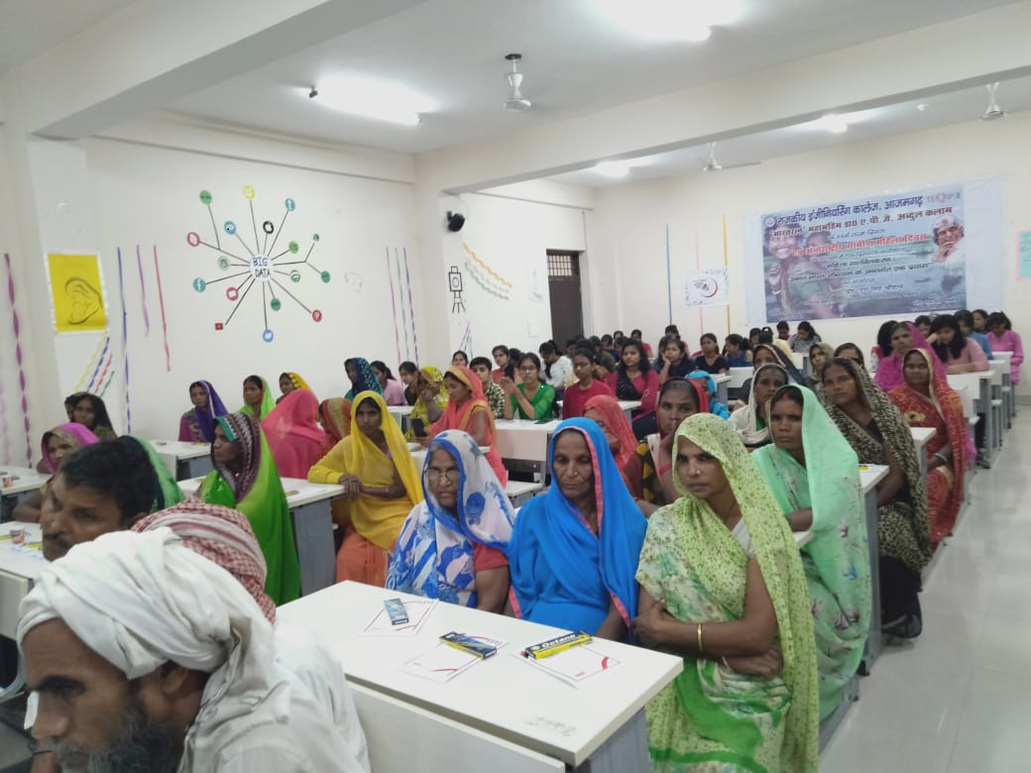

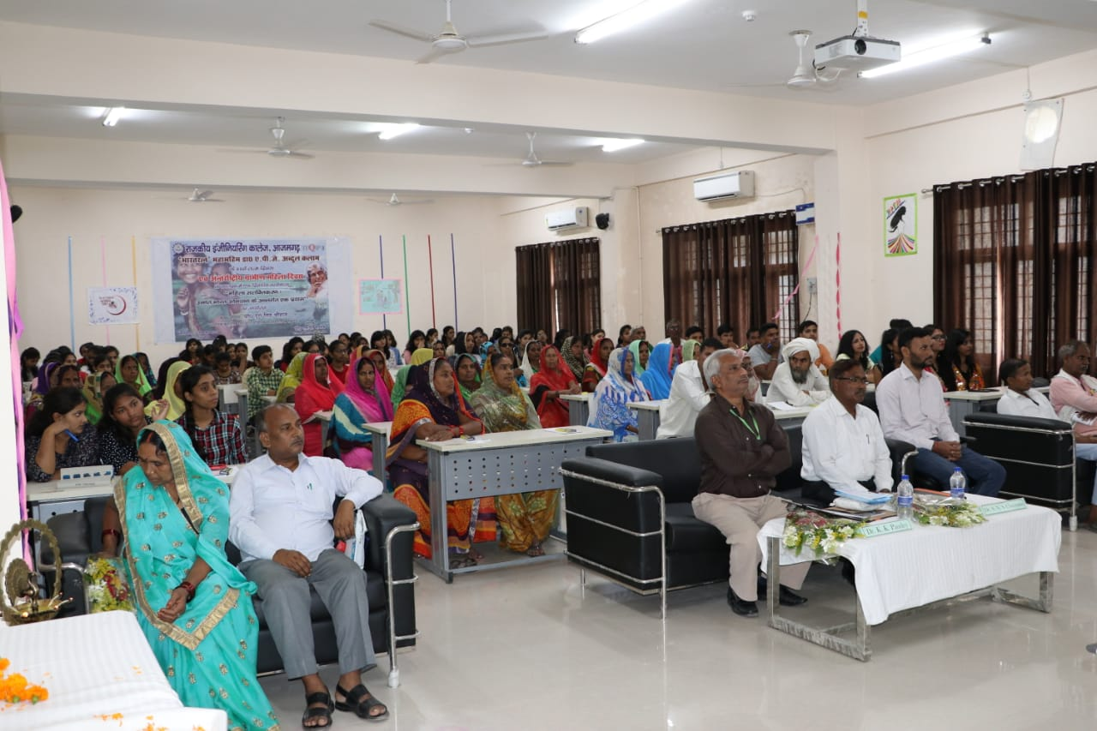

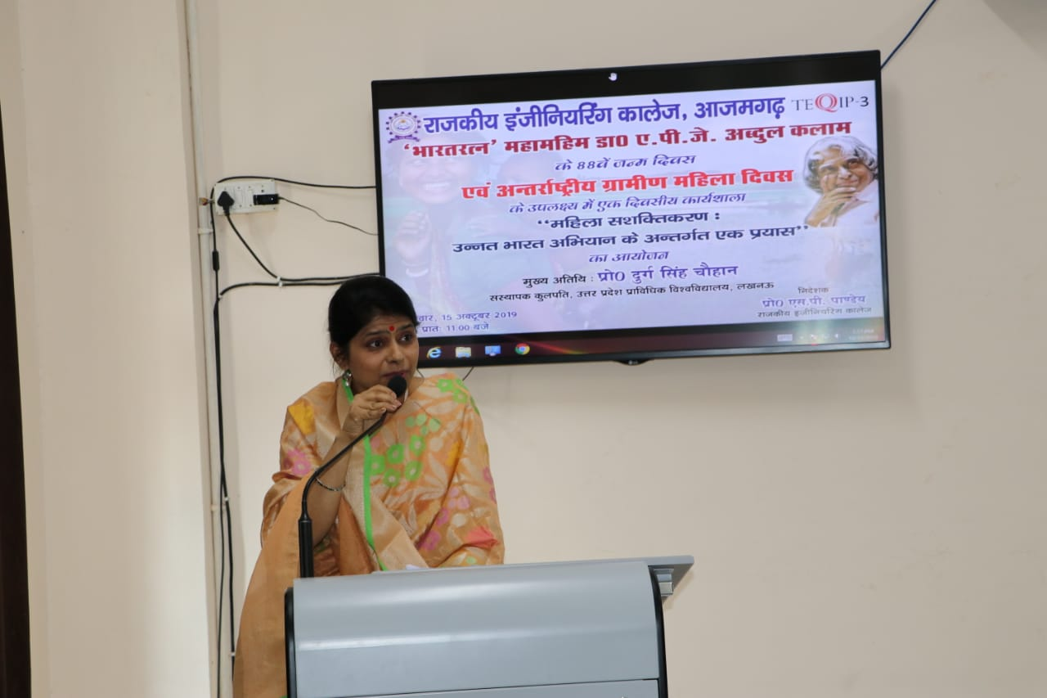

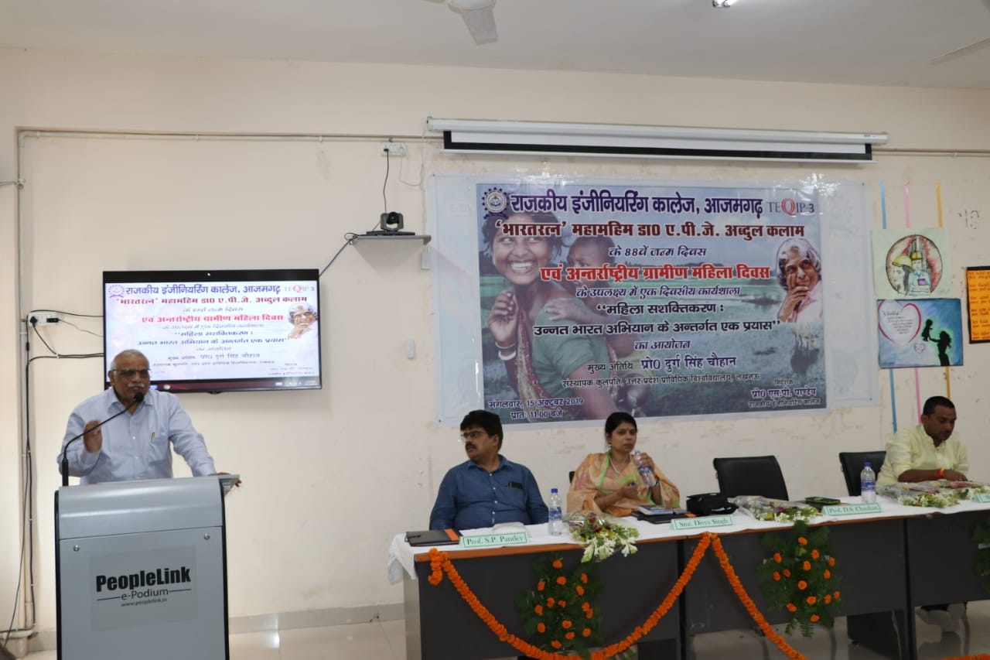

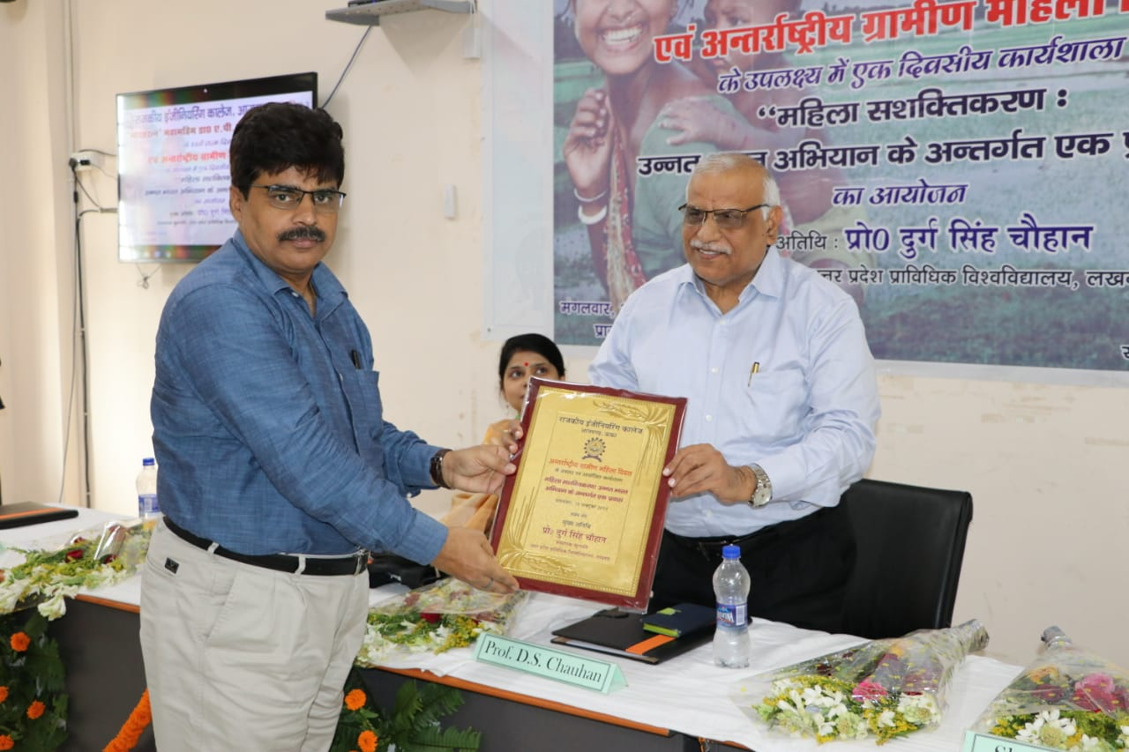

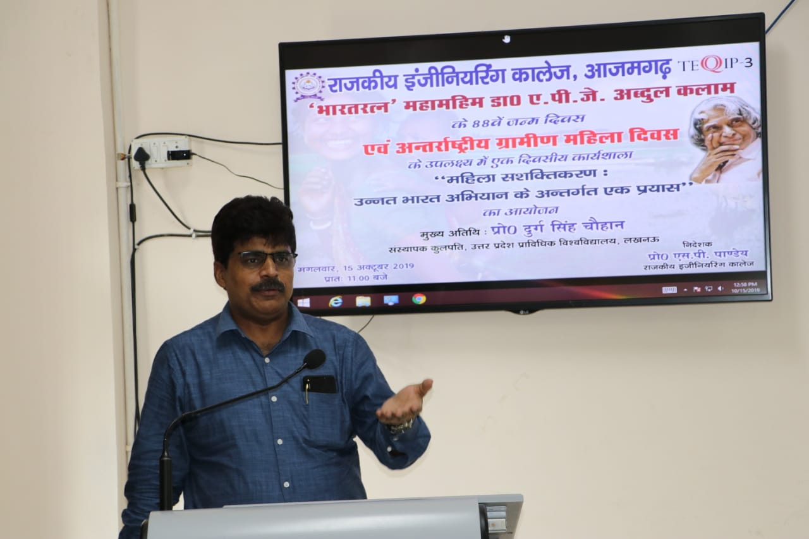

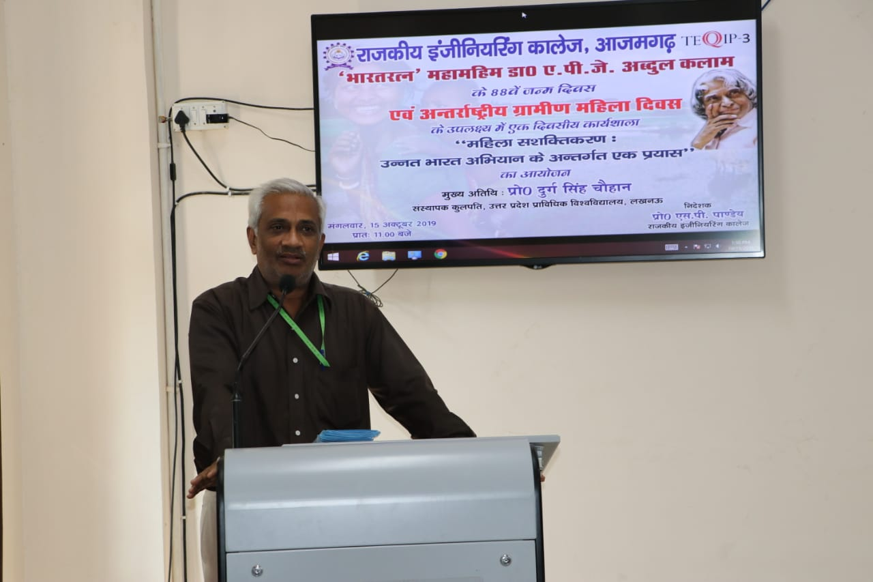

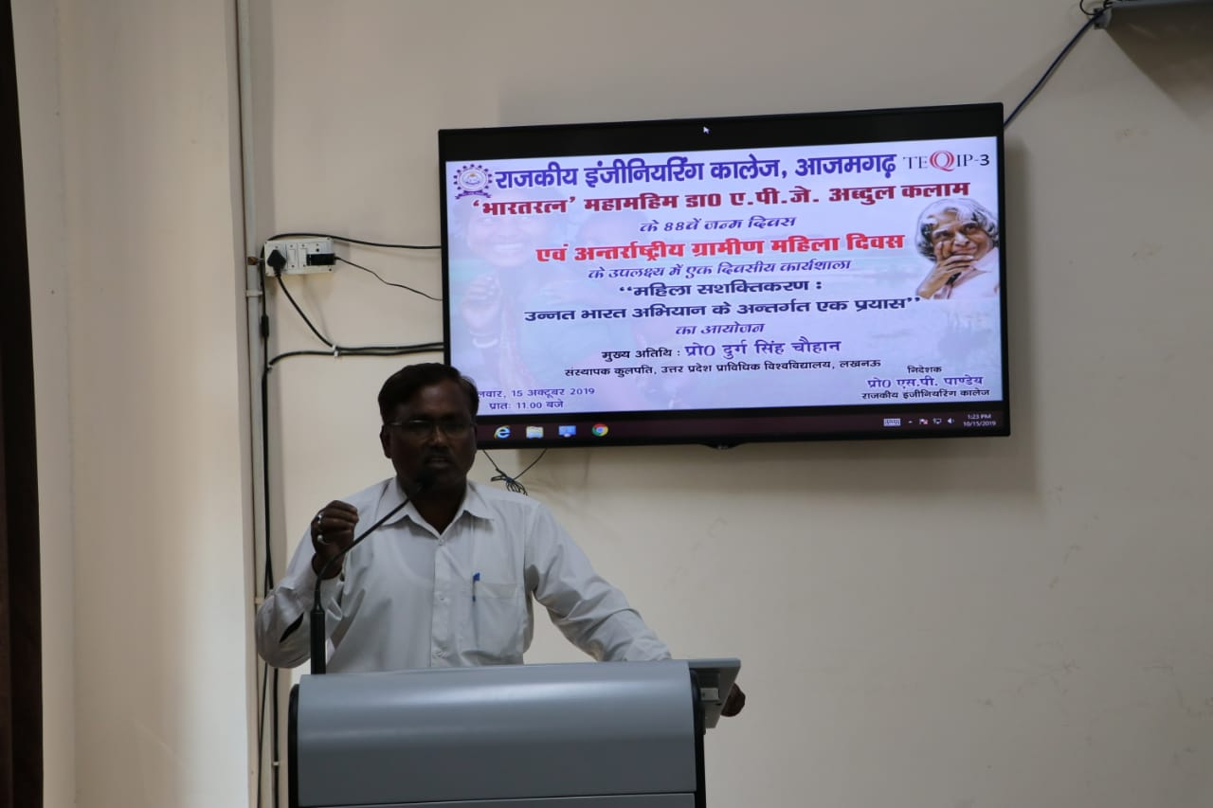

Speakers of this programme shares their views and experience about:

1. Importance of rural women in the growth of a Nation.
2. Rural women are an integral part of the society and plays an important role in making a good society.
3. How to increase participation of women from rural areas in the development of society and Nation?
4. What are the new rules and regulations developed by government of India in favour of rural women?